Comoros

## Freedom House political status

The data set shows the Freedom House political scores and status of the country each year.

## # A tibble: 19 x 5  
## country iso3c date mean status   
## <chr> <chr> <dbl> <dbl> <chr>   
## 1 Comoros COM 1996 4 Partly Free  
## 2 Comoros COM 1998 4.5 Partly Free  
## 3 Comoros COM 2000 5 Partly Free  
## 4 Comoros COM 2002 4.5 Partly Free  
## 5 Comoros COM 2003 4.5 Partly Free  
## 6 Comoros COM 2004 4 Partly Free  
## 7 Comoros COM 2005 4 Partly Free  
## 8 Comoros COM 2006 3.5 Partly Free  
## 9 Comoros COM 2007 4 Partly Free  
## 10 Comoros COM 2008 3.5 Partly Free  
## 11 Comoros COM 2009 3.5 Partly Free  
## 12 Comoros COM 2010 3.5 Partly Free  
## 13 Comoros COM 2011 3.5 Partly Free  
## 14 Comoros COM 2012 3.5 Partly Free  
## 15 Comoros COM 2013 3.5 Partly Free  
## 16 Comoros COM 2014 3.5 Partly Free  
## 17 Comoros COM 2015 3.5 Partly Free  
## 18 Comoros COM 2016 3.5 Partly Free  
## 19 Comoros COM 2017 3.5 Partly Free

## Freedom House classification of political change

The data set shows the GDP growth and the ecomic growth classification of the country each year.

## # A tibble: 19 x 4  
## country iso3c date politicalChangeFH  
## <chr> <chr> <dbl> <chr>   
## 1 Comoros COM 1996 no change   
## 2 Comoros COM 1998 no change   
## 3 Comoros COM 2000 no change   
## 4 Comoros COM 2002 democratization   
## 5 Comoros COM 2003 no change   
## 6 Comoros COM 2004 democratization   
## 7 Comoros COM 2005 no change   
## 8 Comoros COM 2006 democratization   
## 9 Comoros COM 2007 autocratization   
## 10 Comoros COM 2008 democratization   
## 11 Comoros COM 2009 no change   
## 12 Comoros COM 2010 no change   
## 13 Comoros COM 2011 no change   
## 14 Comoros COM 2012 no change   
## 15 Comoros COM 2013 no change   
## 16 Comoros COM 2014 no change   
## 17 Comoros COM 2015 no change   
## 18 Comoros COM 2016 no change   
## 19 Comoros COM 2017 no change

## Freedom House score trend

The plot shows the Freedom House scores trend of the country.

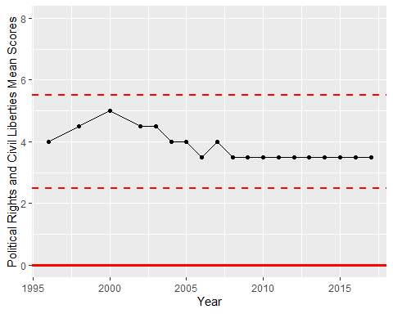

Freedom House Score Trend